**Section – A**

1).

int[] days_per_months={31,28,31,30,31,30,31,31,30,31,30,31};

int[][] rain_data = new int[12][];

for (int i = 0; i < 12; i++){

rain_data[i]=new int[days_per_months[i]];

}

2).

public static void inputRainData(int[][] rain_data){

Scanner input = new Scanner(System.in);

for(int i=0; i<rain_data.length; i++){

for(int j=0; j<rain_data[i].length; j++){

System.out.print("Input "+(i+1)+" month "+(j+1)+" day weather : ");

rain_data[i][j] = input.nextInt();

}

}

}

**Section – B**

Q1).

import java.util.*;

class Example{

public static void main(String args[]){

Scanner input = new Scanner(System.in);

int physics;

int chemistry;

int maths;

int total;

double average;

System.out.print("Enter physics Marks : ");

physics = input.nextInt();

System.out.print("Enter chemistry Marks : ");

chemistry = input.nextInt();

System.out.print("Enter maths Marks : ");

maths = input.nextInt();

total = physics+chemistry+maths;

System.out.println("Total: "+total);

average = total/3;

System.out.println("Average: "+average);

System.out.println("Total subjects marks is: "+total);

if(average>=65){

System.out.println("The student is eligible");

}else{

System.out.println("Not eligible");

}

}

}

Q2).

import java.util.*;

class Example{

public static int mode(int a[],int n) {

int minValue = 0, minCount = 0;

for (int i = 0; i < n; i++) {

int count = 0;

for (int j = 0; j < n; j++) {

if (a[j] == a[i])

count++;

}

if (count > minCount) {

minCount = count;

minValue = a[i];

}

}

return minValue;

}

public static void main(String args[]){

int n = 5;

int a[] = {27,15,15,11,26};

System.out.println("Mode :"+mode(a,n));

}

}

Q3).

a).

for-loop,while-loop,do while-loop,for each

b).

while-loop-->the code repeat again and again if the condition is true,

do while-loop-->in do while-loop the condition is tested at the end of the loop.if the condition is true the loop is working at lease one time

c).

This loop is use for only to read.

Ex-

import java.util.*;

class Example{

public static void main(String args[]){

int[] array={1,2,3,4,5,6,7,8,9};

for(int a : array){

System.out.print(a+", ");

}

}

}

d).

import java.util.*;

class Example{

public static void main(String args[]){

Scanner input= new Scanner(System.in);

int[] ar=new int[10];

int negative=0;

int positive=0;

int zero=0;

for (int i = 0; i < ar.length; i++){

System.out.print("input a number : ");

ar[i]=input.nextInt();

if(ar[i]<0){

negative++;

}

if(ar[i]>0){

positive++;

}

if(ar[i]==0){

zero++;

}

}

System.out.println("negative : "+negative);

System.out.println("positive : "+positive);

System.out.println("zero : "+zero);

}

}

Q4).

a).

class Example{

public static void main(String args[]){

int x=0;

System.out.println(x++);

System.out.println(x);

}

}

*The variable is incremented after that line.

Pre increment

-------------

class Example{

public static void main(String args[]){

int x=0;

System.out.println(++x);

System.out.println(x);

}

}

*The variable is incremented before evaluated.

b).

Casting is process that converts a data type into another data type in both ways manually and automatically.

Converting one primitive datatype into another is known as type casting.

There is also narrow casting and wider casting.And wider conversion and narrow conversion.

Ex:-

Wider conversion

class Example{

public static void main(String args[]){

double d;

char ch='A';

d=ch;

}

}

Narrow conversion

class Example{

public static void main(String args[]){

long x=123456;

byte b=10;

// b=b+x; // Illegal

b+=x;

}

}

Wider casting

class Example{

public static void main(String args[]){

int total=234;

int N=10;

double avg;

avg=total/N;

avg=total/(double)N;// Wider casting

avg=(double)total/N;// Wider casting

}

}

Narrow casting

class Example{

public static void main(String args[]){

double d=65.12345;

char ch;

//ch=d;//Illegal

ch=(char)d;// Narrow casting

}

}

c).

import java.util.*;

class Example {

public static void main(String[]args){

Scanner input=new Scanner(System.in);

System.out.print("Input temperature : ");

int temperature= input.nextInt();

switch (temperature){

case 20:{

System.out.println("Fan Start");break;}

case 50:{

System.out.println("On the Air Cooler");break;}

}

}

}

d).

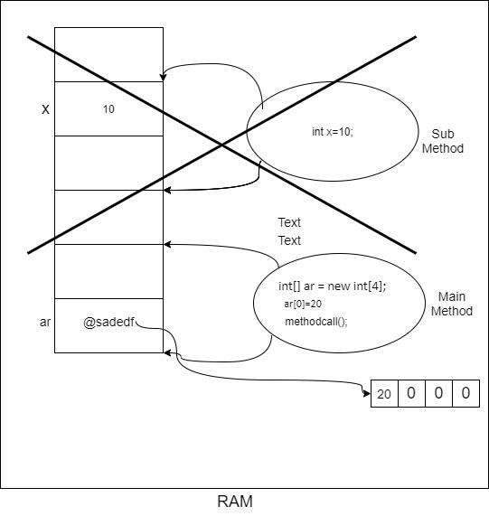

**Section – C**

Q1).

import java.util.*;

public class Example{

public static void main (String [] args) {

int [] array = {45,12,85,32,89,39,69,44,42,1,6,8};

int temp;

for (int i = 1; i < array.length; i++) {

for (int j = i; j > 0; j--) {

if (array[j] < array [j - 1]) {

temp = array[j];

array[j] = array[j - 1];

array[j - 1] = temp;

}

}

}

for (int i = 0; i < array.length; i++) {

System.out.println(array[i]);

}

}

}

Q2).

Q3).

import java.util.*;

public class Example{

public static void main(String args []) {

Scanner input=new Scanner(System.in);

System.out.print("Input Number : ");

int num=input.nextInt();

int sum=0;

while(num!=0){

sum+=num%10;

num/=10;

}

System.out.println("Sum of digits : "+sum);

}

}